Assignment 5

Brent Schoenmakers & Cihan Kurt



# Task 1: Choose at least one IoT protocol next to HTTP.

Our choice for this task will be MQTT. This because the school offers us enough tools to do this.

# Task 2: Implementation

The code for the HTTP and MQTT can be found in the .ino files. These are zipped together and submitted. Just a short description about the code:  
  
HTTP:  
- The Arduino connects to 12connect.  
- The Arduino hosts a webpage with just two lines of text as the content. The Arduino gives (serial print) the IP address of the webpage.   
- Both lines have a hyperlink with a GET request. “/H” and “/L”. When the first message has been received, the LED should be turned on. When the second message has been received, the LED should be turned off.

MQTT:  
- The Arduino connects to 12connect.  
- The Arduino will connect to the given MQTT topic with the given credentials. This one is being hosted at apps.fhict.nl/selfservice  
- The callback() function will be called when there is a new message published on the specific topic.  
- The callback function has a payload with a length as parameters. Thanks to the length we can avoid reading unnecessary characters.  
- If the received message equals “SwitchLed” the led will be turned on or off. (depending on the current state of the led).

# Task 3: Performance differences

We can’t really tell which one is better, because the messages we are sending are really short.  
But we will do this research for just this particular situation.  
  
**User comfort:**

*HTTP:*Sometimes it takes a long time to actually get the webpage up and running.   
The website gets offline when the Arduino receives to many messages (spam).  
Even when not spamming, it takes a long time sometimes to actually perform the request.  
  
*MQTT:*It takes some time to connect to the topic, but it takes a short amount of time than HTTP.  
Publishing a message to the topic does not happen through the Arduino. So that can’t be an issue here.   
Receiving a message happens really fast and it’s always exactly the right message.

**Speed:**We used Wireshark to measure the speed differences.

*HTTP:*The GET Request starts at time; 5.4 and ends at time: 6.2. That’s a difference of 0.8 seconds.  
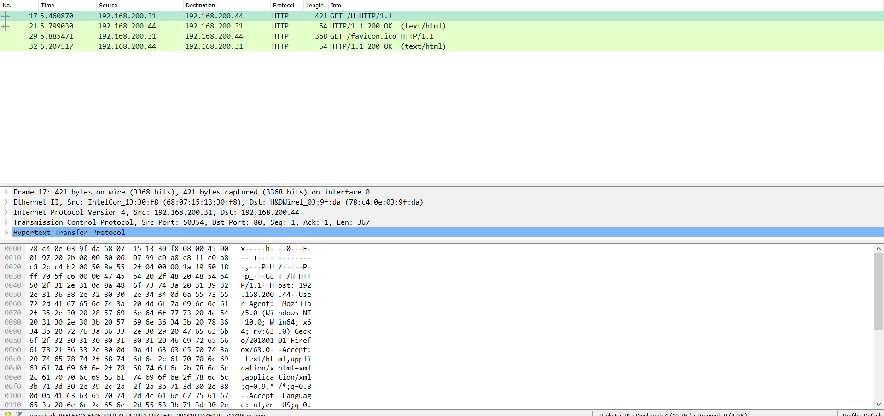

*MQTT*

The connect command starts at 5.91 while the disconnect command is at 5.92. This is a difference of just 0.01 seconds. This is really quick compared to the HTTP request.

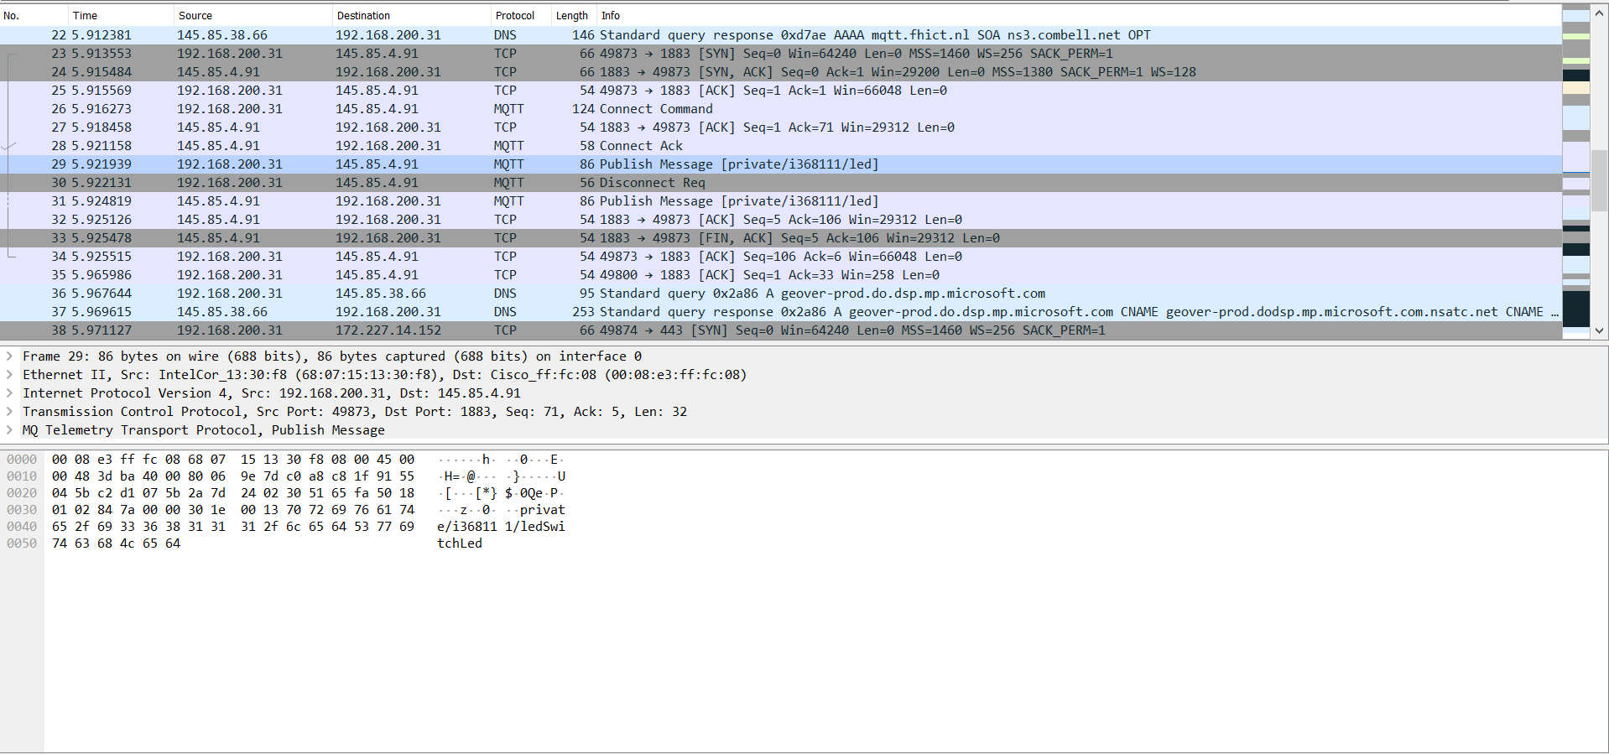

**Package size:**

We did take a look at the actual packages of both protocols. The size of the MQTT package is a lot smaller than the HTTP package. This can be seen in the pictures above.

**Conclusion:**MQTT is, for us, the winner of all the three subjects. It’s faster, it’s more reliable and it has a less package size.